HOW TO CONFIGURE DHCP RELAY AGENT

IP HELPER-ADDRESS CONFIGURATION

Inacio Andre

2024

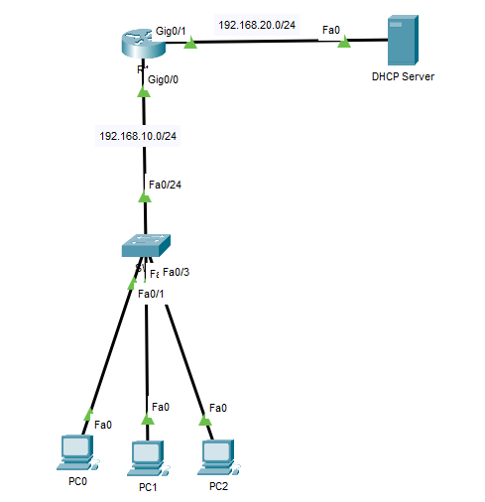

R1

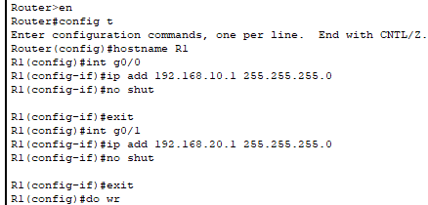



DHCP SERVER

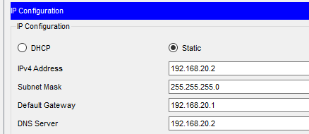

DHCP POOL

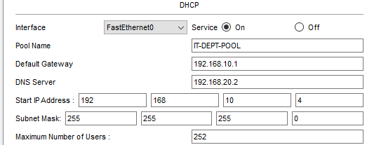

PC0

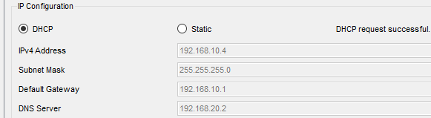

PC1

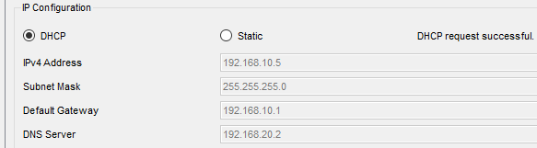

PC2

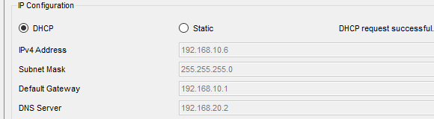

PC0-TO-PC1

